Technical Study
Prepared by: TSc

User Interface
Hvordan præsenterer produktet sig for brugeren rent betjenings mæssigt? Skitsér for- og bagpladen, og beskriv hvordan apparatet skal forbindes til “omverdenen”. Beskriv hvordan apparatet betjenes i alle situationer

Mechanical Design/Styling
Hvordan ser apparatet ud? Størrelse og vægt? Anvendte farver, knapper og displays? Passer det design mæssigt med andre PTV (eller andre) apparater, det må forventes, det skal kunne arbejde sammen med?

Technical Description
Beskrivelse af apparatet og de anvendte kredsløb på - mindst - blok-diagram-niveau.

Main Instrument Functions
- 3 fine timeable analog blackburst generators.
- 1 analog color/black generator with coarse timing.
- 1 SDI color/black generator with coarse timing.
- 1 AES / EBU generator with Wclk.
- Remote control via RS232 interface.
- Genlock input.
- Master controller.

Instrument Block Diagram

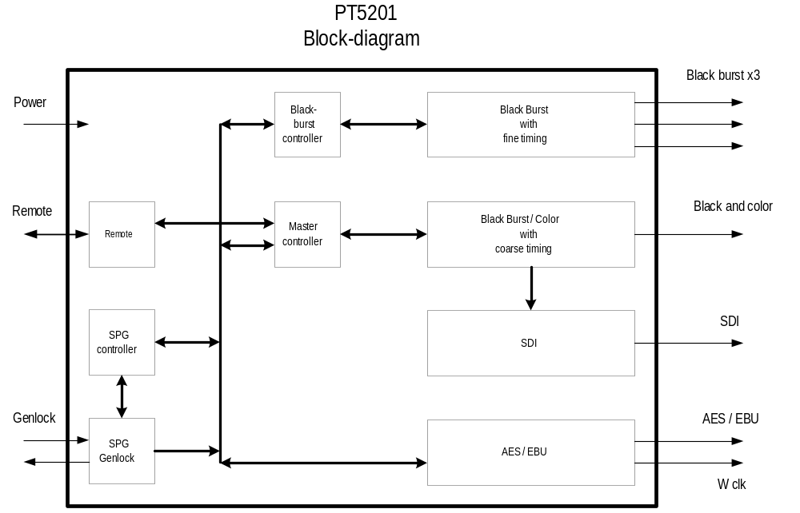

Description of Instrument Block Diagram

- The 3 blackburst generators are designed with one PLD (FLEX6016A) and one controller (XA). The PLD handles the signal generations and the controller handles the signal-type, the timing and the communication with the master-controller. This sulotion are chosen to meet the cost requirements since DSP, other PLD and mulitplier solutions will increase the costs.
  - The SDI and analog color/black generator and the AES / EBU generator will use only one PLD MAX7256 or similar to make these generators more cost effecient. The controller functions handles by the master-conrtoller.
- The remote control uses a RS232 interface.
- The SPG handles the genlock function both external and internal and makes all the sync-signals and the master osc. for the PT5201.
- The Master controllers main purpose is to handle the user interface communication with the apparatus, (through an RS232 interface), i.e. to distribute user-settings/status to/from the distributed processor-systems handling the black burst generators and SPG&Genlock function. It furthermore handles the coler/black-generator functions.

